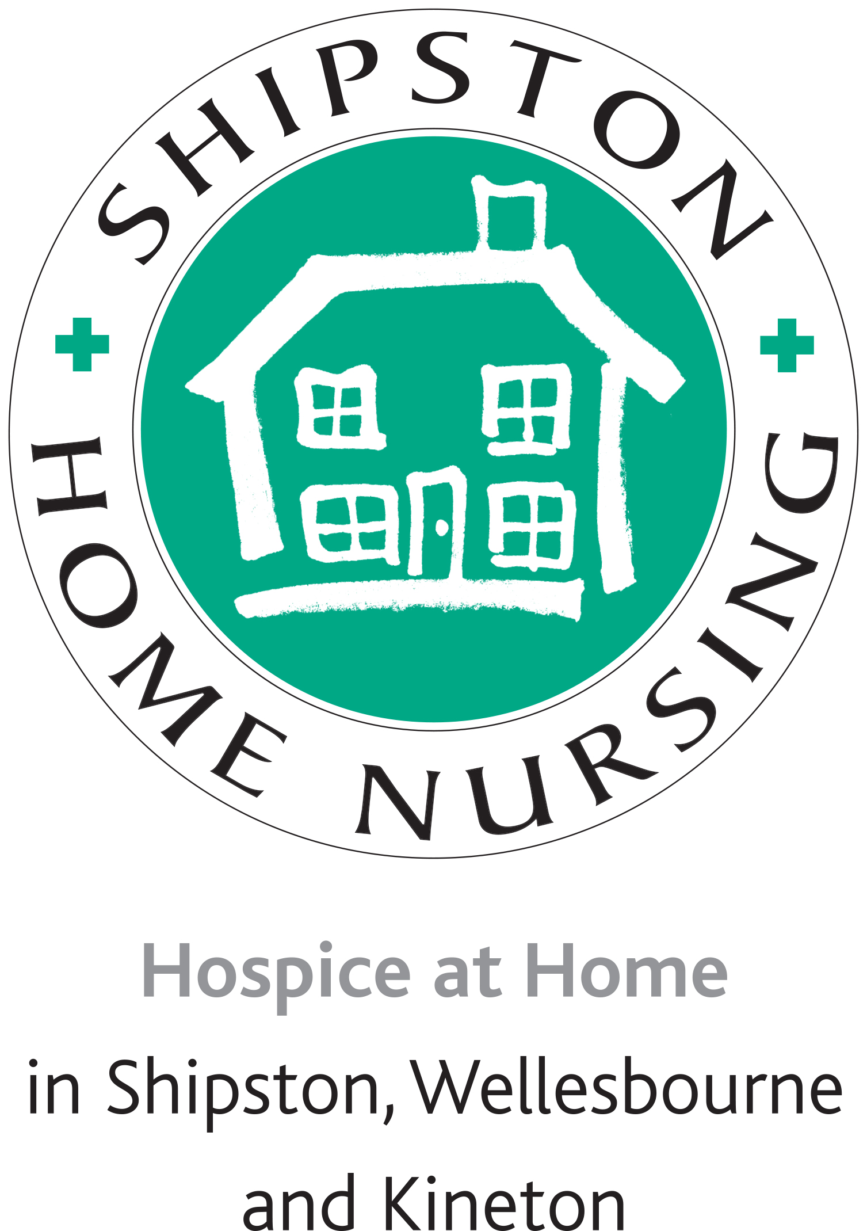
The Shipston Home Nursing 10k Sponsored Run or Walk
SPONSORSHIP FORM
Sunday 15th April 2018, Walton Hall, Walton, Wellesbourne, CV35 9HU.
Arrive at 8.45am for registration for a 10.00am start
Entry cost: Adults £5, children £3
(Children under 12 must be accompanied by an adult)
All participants take part at their own risk. Shipston Home Nursing cannot be held responsible for accident or injury.
BOOST YOUR DONATION If you are a UK taxpayer and have paid enough tax, we can claim an extra 25p for every £ you donate, at no cost to you. Tick Gift Aid box below. I am UK taxpayer and understand that if I pay less income tax and/or capital gains tax than the amount of gift aid claimed on all my donations in that tax year it is my responsibility to pay any difference. Please keep this form safe, we need you to return it to us to claim Gift Aid. If you need more sponsorship forms, please photocopy this one. Registered Charity Number. 1162586
Sponsors can also donate through our Justgiving page, which can be found on the SHN website at www.shipstonhomenursing.co.uk.
Please send this form and return all money to Rebecca Mawle or Debbie Foster at
Lower Farm Barn, Great Wolford, Warks, CV36 5NQ.
Name........................................................................................................................................
Address....................................................................................................................................
Email ...................................................Telephone....................................................................
Sponsor Name | Address/Email | Amount paid | Gift Aid  (tick) | Date Received
Sponsor Name | Address/Email | Amount paid | Gift Aid  (tick) | Date Received

